TEAM ID: PNT2022TMID36989

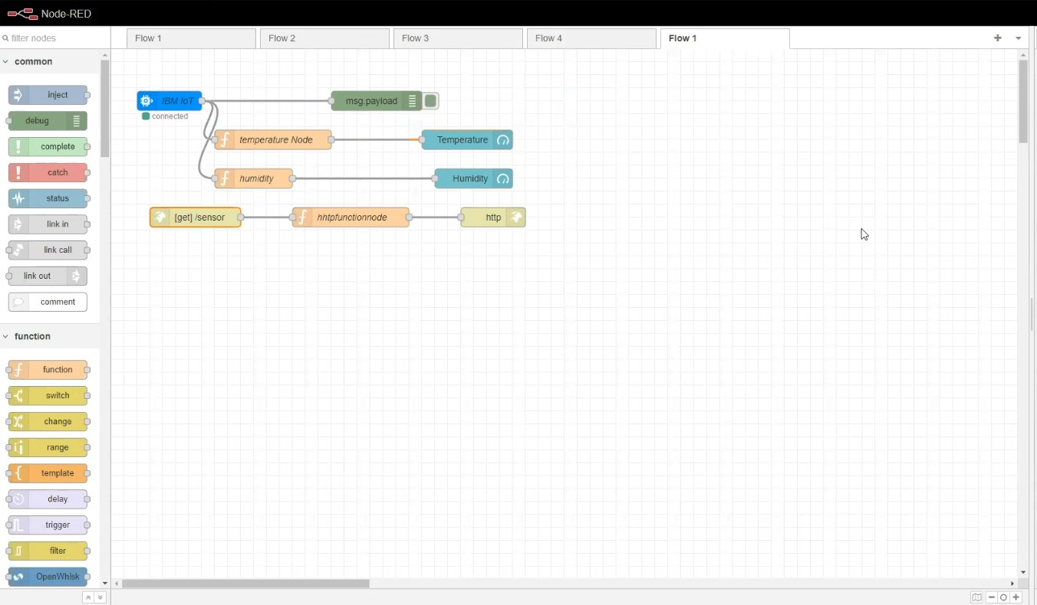

FIGURE 1

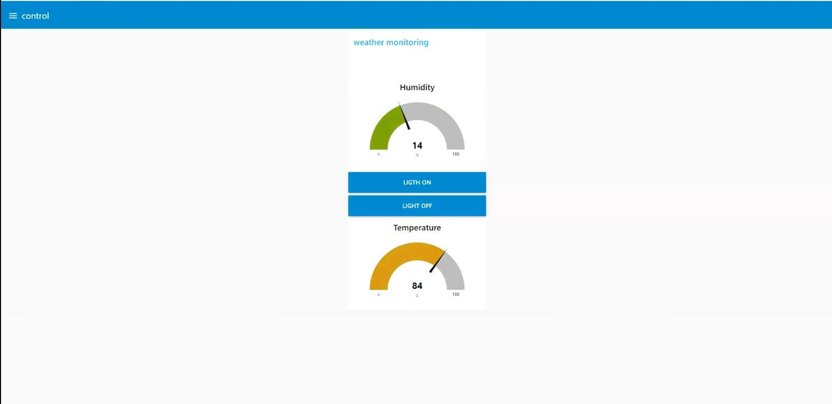

FIGURE 2